Lab2: Importing Type Trees using COBOL Copybook

Objective

Equip you with an understanding of importing a COBOL copybook.

By completing the exercises you will learn how to import the COBOL COPYBOOK in order to generate the typetree.

COBOL Copybook Importer

The COBOL Copybook Importer imports the definition of one or more COBOL copybooks in a file and generates a type tree that contains the corresponding type definitions. The copybook file may contain more than one COBOL copybook. If your file contains multiple COBOL Copybook definitions, all definitions are contained in a single type tree. The importer uses a series of maps to convert the copybook format into a type tree script file (.mts). The Type Tree Maker then processes this type tree script and generates a type tree that contains all of the supported types that are defined in the copybook.

The COBOL Copybook Importer is used to automatically generate either COBOL Copybook type trees or Customer Information Control System (CICS) type trees. The metadata for both is in the form of COBOL copybooks .

Environment

Windows OS, WTX8.4 Design Studio.

List of components

- wrapped.cpy
- wrapped.mtt

Procedure

Step 1:

Start menu->Programs-> WebSphere Transformation Extender 8.4 ->Design Studio-> Design Studio.

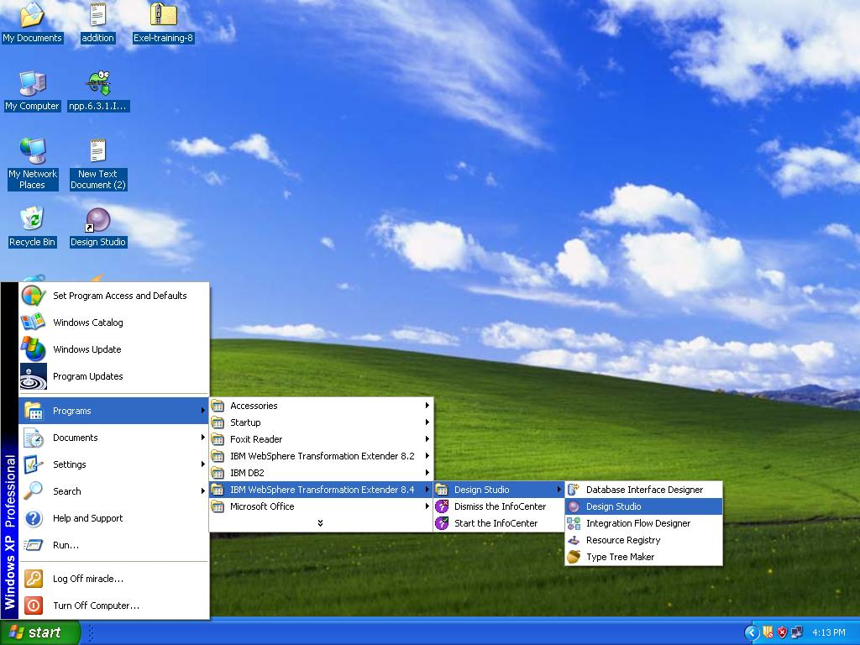

Step 2:

Open the WebSphere Transformation Extender Design Studio and click the OK button to accept the default workspace location or you can browse your own location.
Here location C:\WTXTraining\WTX8.4 has been used.
The workspace is the physical directory where your artifacts will be stored.

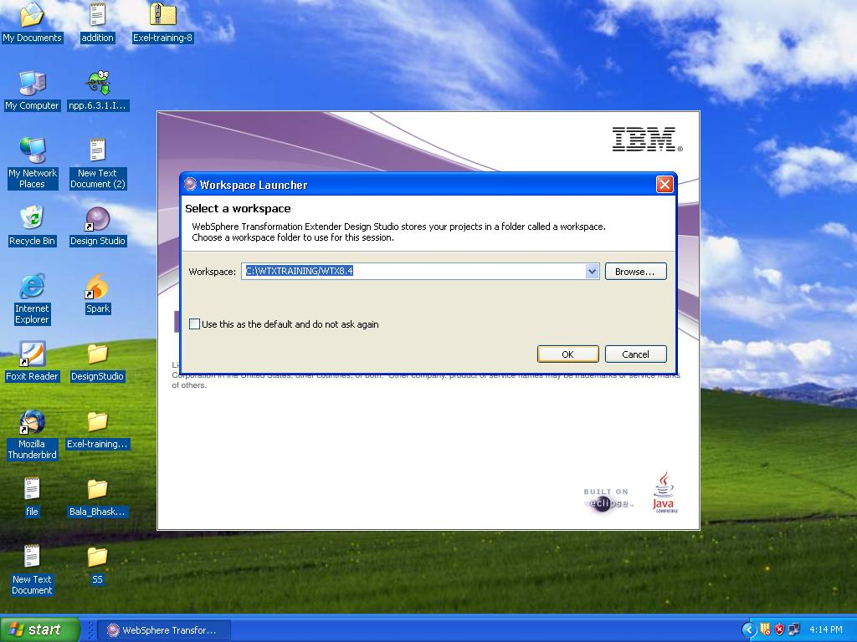

Step 3 : Import a type tree

We can import a typetree by 2 ways.

1st method

From the menu, choose File→Import.

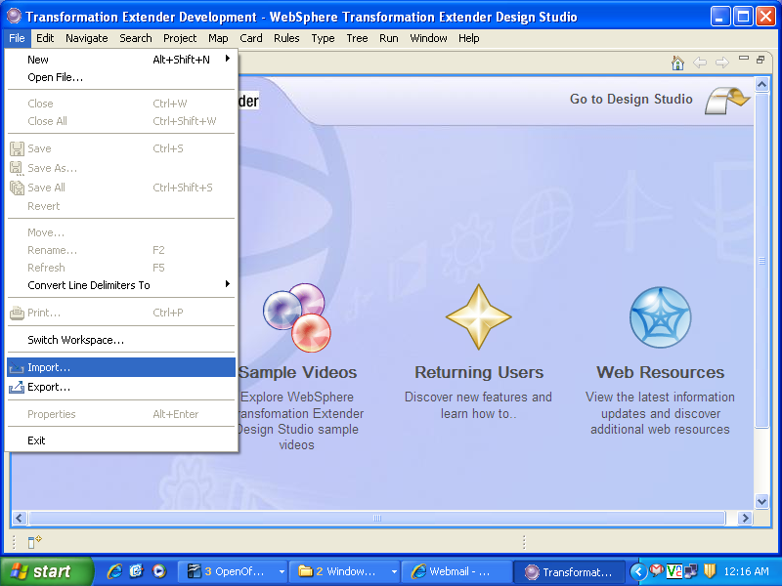

Step 4:

The Importer Wizard – dialog box appears, enabling you to select the COBOL Copybook to import.

Go to Transformation Extender and Select COBOL Copybook from the Importer Wizard dialog box and click Next.

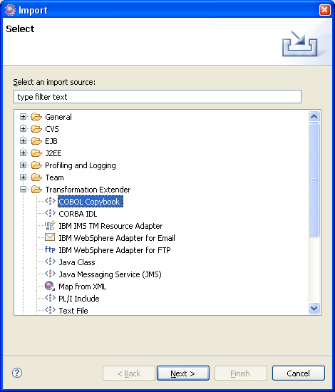

Step 5 : Import a type tree - Contd.

2nd method

Right-click Type Trees in the WTX_Lab2 project.

Select the Select the Import->COBOL Copybook which will direct to the screen shown in the Step 6.

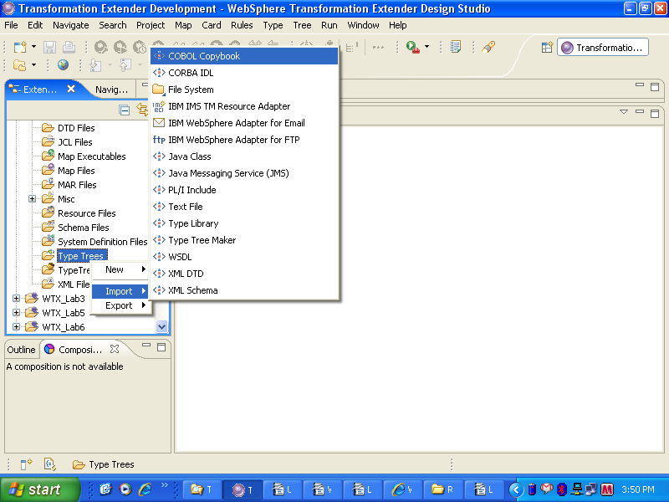

Step 6:

In the Importer wizard dialog select option COBOL copybook and click Next

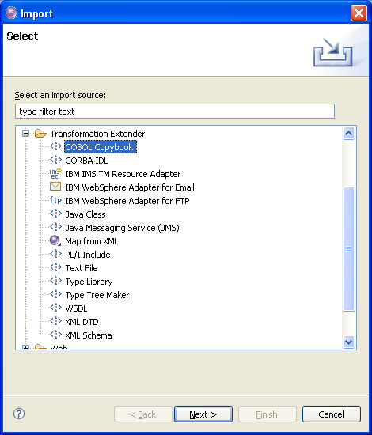

Step 7 :

Browse to the file location, C:\WTXTraining\WTX8.4\WTX_Lab2\wrapped.cpy, you wish to import and click Next.

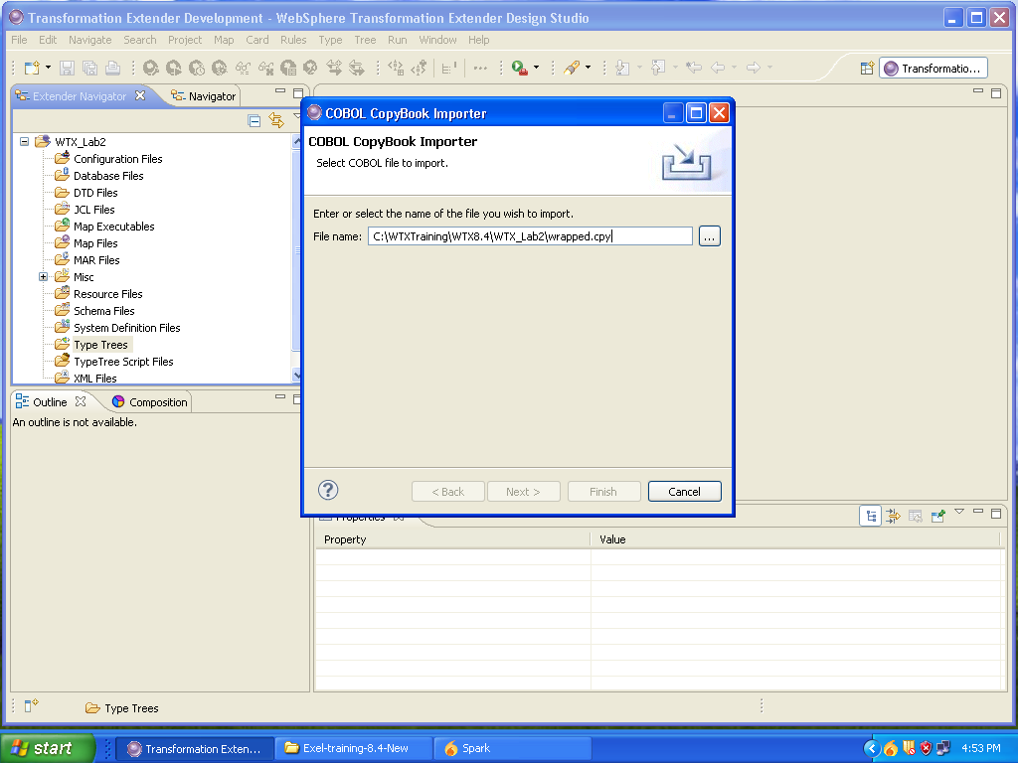

Step 8:

Accept the defaults (NATIVE), which means that the character set collating sequence is native to the platform (i.e. EBCDIC for z/OS and ASCII for Unix or Windows).Click Next

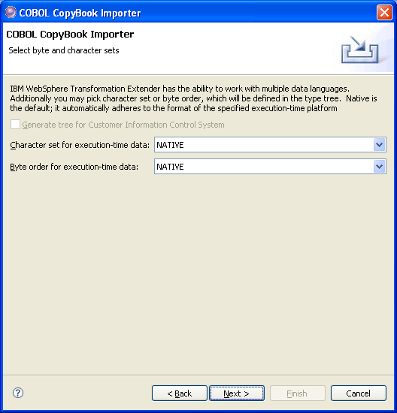

Step 9:

Click WTX_Lab2 to move it to the “Enter or select the parent folder” window. Enter the name of the typetree of the file you wish to create or select a file name. In this example we are giving a name wrapped.mtt and select Next.

The destination file will be overwritten if it exists.

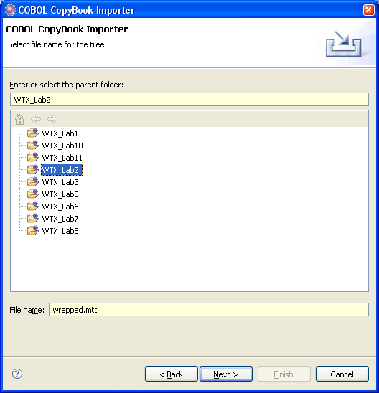

Step 10 :
When the type tree is successfully created, click Finish.

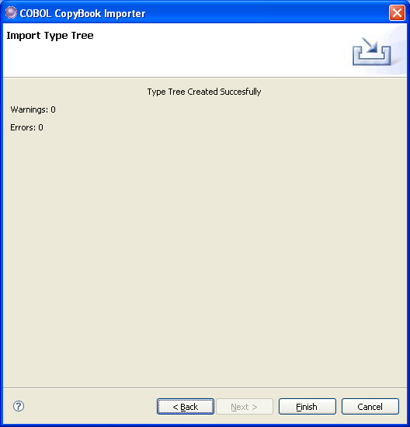

Note : If errors are detected, a message box is displayed giving you the option to view the errors and warnings. If you click Yes, a dialog box appears displaying errors and warnings.

Step 11: View the Type Tree

You will be prompted to open the Type Tree. Click Yes.

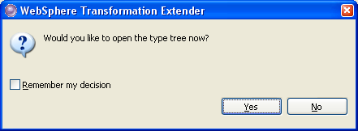

The typetree wrapped.mtt is created.

Step 12 :

We are finished except for analyzing the tree for logical errors and inconsistencies. From the menu, choose Tree Analyze Structure and Logic Only or use the Analyze logic only icon on the toolbar:

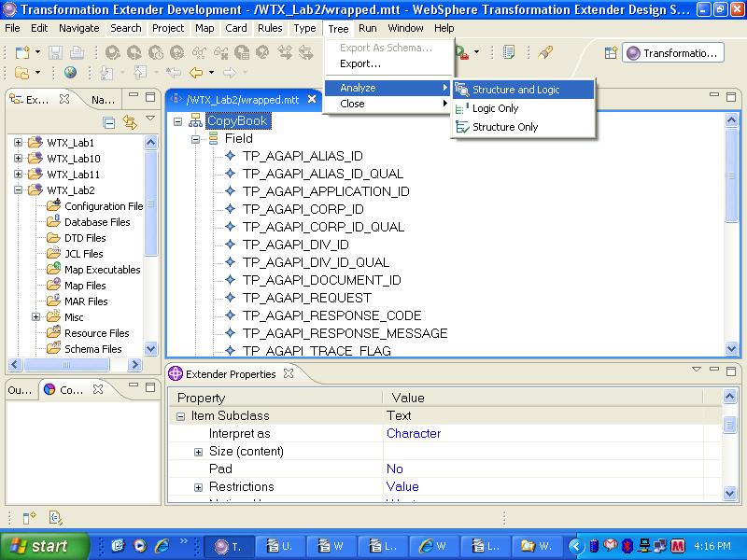

Step 13:

Close the Analysis Results window and go the menu, choose File→Save (or use the Save icon from the toolbar) to write the changes to disk.

The tree is now ready to be used in a map.

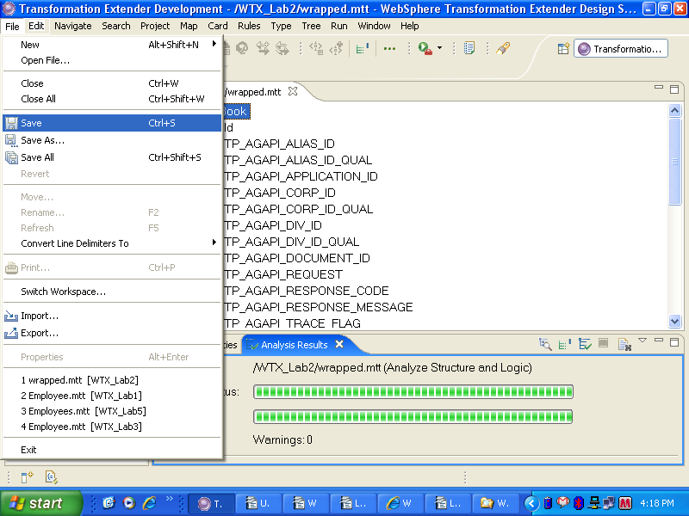

Limitations & Constraints

The COBOL Copybook Importer does not handle certain COBOL features that may be in the definition file. If an unsupported statement is encountered, a warning message appears. Types for the following COBOL statements must be added manually to the type tree that is generated by the Importer.

The COBOL Copybook Importer does not support the THROUGH option in the VALUES clause. The range of values must to be added manually to the restriction list for the level 88 item(s) that use the THROUGH clause. Alternatively, a component rule could be placed on the item where it is used. For example, an item defined as follows in the copybook .
15 CODE-ID PIC X(1).
88 OTM-TRD-GSP VALUE `A' THROUGH `F'.
could have a component rule specified as: $ >= "A" & $ <= "F"
If you are not concerned with validating codes and/or values in your input data that conforms to the copybook definition for a particular item, delete the entire restriction list generated by the COBOL Copybook Importer.

The COBOL Copybook Importer does not expand any embedded COPY clauses. The data included in the embedded COPY clauses must be manually added to the type tree or added to the copybook before you run the wizard.

